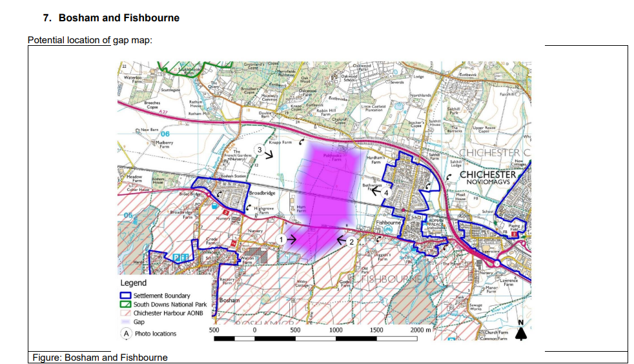
The gap identified is not open land and is fenced off on one side and hedged off on the other side of the road. Ham Farm identified as part of the gap, is a privately owned commercial site which is screened off. The first open land on either side between the settlements of Bosham and Fishbourne is Highgrove Farm and the land opposite. Highgrove Farm is the proposed site for policy A11.

