To Chichester District Council

From Nigel Searle MBE MILT ACIRO, Strategic Planning, GTR

Subject Chichester District Local Plan consultation response

Date 17th March 2023

Background

GTR are contracted by the Department for Transport to operate train services in a large area of London and the Southeast.

Rail travel in Chichester District is dominated by Chichester, attracting large numbers of passengers to visit the city for leisure purposes, work, education and business from a wide range of communities. Southbourne station generates a moderate flow of passengers 40% of whom travel to/from Chichester 29% to/from Havant or Portsmouth. Fishbourne, Bosham and Nutbourne stations generate very small numbers of passengers

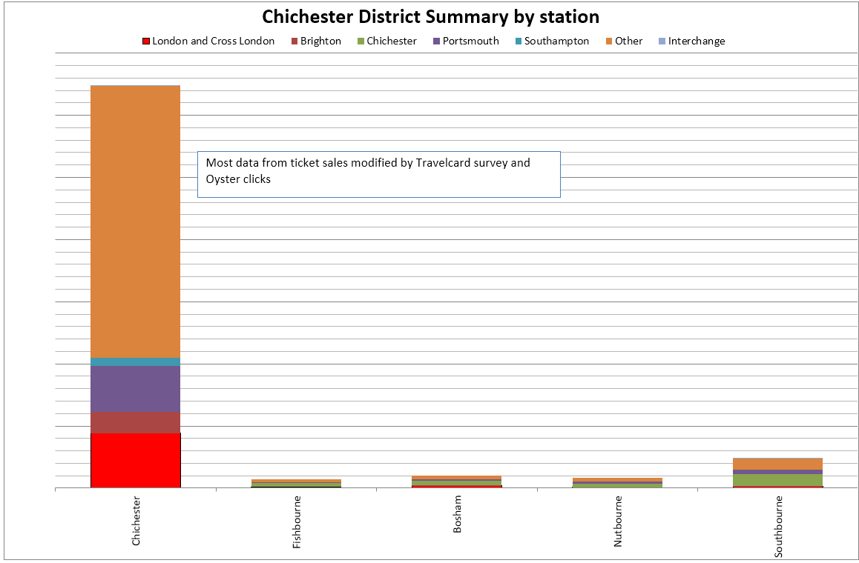

Before 2007 only 15% of people who travelled between Chichester and London used the direct train, most drove to other stations such as Haslemere or close London suburbs to catch a train. Following the transformation of the West Coastway train service within 3 years there was a 70% increase in off peak travel on the Arun Valley line driven by the increase of passengers using the direct train between Chichester and London when it was speeded up by 15 minutes by splitting into fast and slow portions. East West passenger use also had a remarkable increase of 10% above background demand.

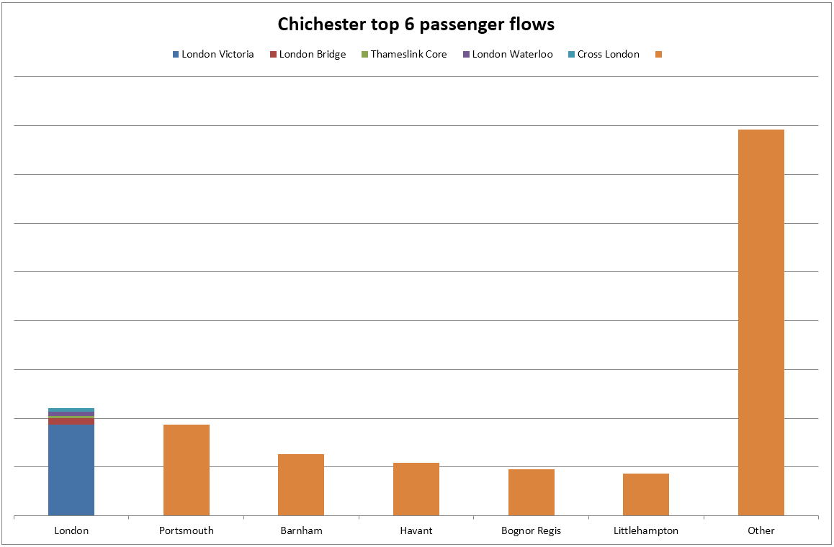

Covid then reduced rail use so. The current Chichester off peak train service consists of

* Half hourly fast trains to London Victoria (1 per hour also serve Southbourne) that are well used for people from Chichester travelling to London and Gatwick Airport.
* 2 trains per hour to Southampton (1per hour also serves Southbourne). These are moderately well used, but poor spacing of trains suppresses their potential.
* 2 semi-fast trains per hour to Portsmouth, (1 per hour also serves Southbourne), these are moderately well used, but spacing could be better, and only 1 per hour goes beyond Portsmouth & Southsea to the Harbour for Isle of Wight and Gosport connections suppressing potential.
* 1 train per hour stopping train to Portsmouth & Southsea serving all stations in Chichester district, that is very poorly loaded except a couple of peak and school trains and are a waste of taxpayers’ money.
* 1 train per hour stopping train to Littlehampton (also serves all Chichester District stations) that has variable loads including peak time standing, but quite low weekday off peak, suppressed due to being only hourly, but Chichester is still the largest destination for rail passengers from Littlehampton.
* 2 trains per hour to Brighton (currently stopping trains due to Covid withdrawal of other stopping trains) These trains are well used with some standing, even off peak, especially Saturday between Chichester and Barnham with passengers connecting for Bognor Regis, and occasionally standing all the way to Brighton

Trains between Chichester District and central London run through the most congested part of the railway Network in south London.



With a growing population, changing demographics and a very congested railway network, it is clear that additional rail infrastructure is required with just a small increase over pre-covid passenger demand. However, indications are that by the 2040’s there will be considerably more passengers than pre-covid.

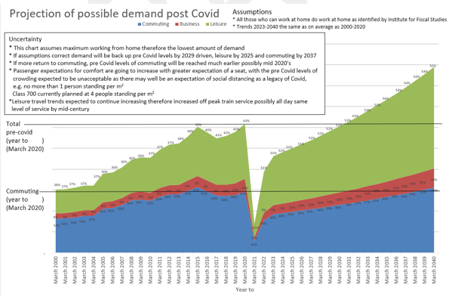Network Rail (NR) has worked up a Brighton Mainline Upgrade Programme (BMUP) to deliver additional train paths between London and the Sussex Coast with delivery of Croydon Area Remodelling Scheme (CARS) critical to providing sufficient capacity to transport all who need to travel between Sussex and London.

The largest concentration of additional dwellings impacting the GTR network south of London are proposed close to stations near the south coast notably Barnham, Chichester, Bognor Regis and Ford. With the current train service, this additional housing does present the risk of trains being full on arrival at Horsham with little space available for Horsham and Crawley passengers. The GTR response to London and South Coast Rail Corridor Study noted that even full BMUP would be insufficient to accommodate growth by mid-century and proposed a new London to South Coast railway to technological advanced standards that would bring Chichester within 60 minutes of central London every 15 minutes.

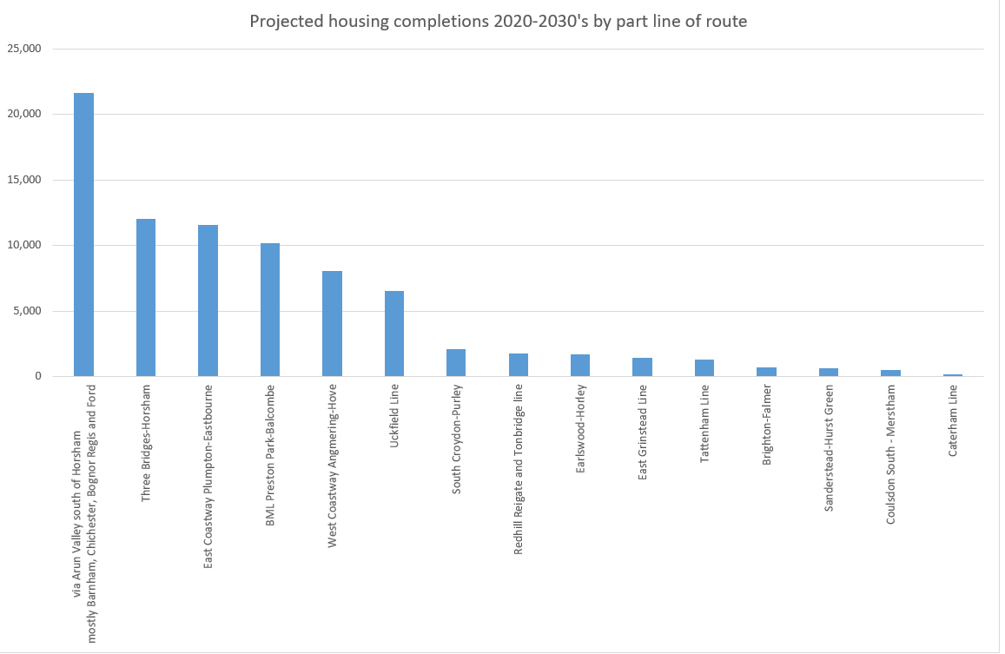

General Principles for new development access to railway stations

A huge barrier to people travelling by train is the first and last mile. Increases of rail use in West Sussex generally stimulate increases in car use due to passengers driving to the station or being dropped off by car as demonstrated by the review into the December 2007 transformation of train services in West Sussex.

When people start journeys by car, very often they continue to their destination, especially for mid distance journeys, because the time taken to park and the cost of parking plus train ticket means there is no benefit to get out the car into the train.

Therefore, it is vital that active travel routes to railway stations meet modern standards.

GTR will support planning developments within active travel distance of railway stations that provide continuous, direct, safe, attractive, comfortable walking and cycling routes between all arears of the proposed developments and railway stations.

* + These walking routes must have the Hierarchy of Road Use designed into them. Streets [Manual for the Streets (publishing.service.gov.uk)](https://assets.publishing.service.gov.uk/government/uploads/system/uploads/attachment_data/file/341513/pdfmanforstreets.pdf) [https://assets.publishing.service.gov.uk/government/uploads/system/uploads/attachment_data/file/341513/pdfmanforstreets.pdf especially chapter 3](https://assets.publishing.service.gov.uk/government/uploads/system/uploads/attachment_data/file/341513/pdfmanforstreets.pdf%20especially%20chapter%203), “The design process from policy to implementation”

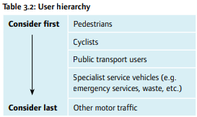

This means where the walking or cycling route conflicts with a motor vehicle route, walking, and cycling priority MUST be designed into the routes so that motor vehicles wait for walkers and cyclists, not the other way around.

The Highway Code has been revised so road user hierarchy is now a fundamental requirement e.g. Rule H2 “At a junction you should give way to pedestrians crossing or waiting to cross a road into which or from which you are turning.”, and this requires the design of road junctions to be changed to make it obvious to the driver that they do not have right of way and have to wait for people walking.

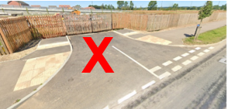

This road junction into a new estate being built is dangerous because it gives the impression motor vehicles have right of way conflicting with the Highway Code.

GTR will object to any planning application for development where continuous walking and cycling routes between the development and railway station are not provided.

Tactile paving dropped kerbs where people walking have to enter a hostile road environment to cross are not acceptable.

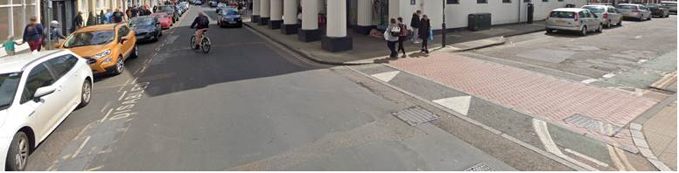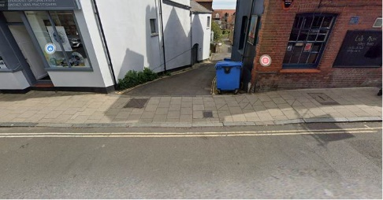The walking and cycling routes MUST be continuous footways and cycleways

|  |  |
| --- | --- |
|  |  |
| *Figure 1 - A continuous cycle path as seen by the cyclist alongside a segregated continuous walking path* | *Figure 2 - Shows vehicle driver perspective of pedestrian and cycle path whereby there is a clear priority for walkers and cyclists and that cars must give way* |

It must be clear to people driving motor vehicles to stop and give way to people walking and cycling.

Traffic light signals to control motor vehicle, active travel conflict should be avoided, as they focus driver concentration on the traffic signal away from what is around them, while the delay to active travel users often result in people taking risks stepping out in small gaps in the traffic as recent analysis of the road at the front of Three Bridges station demonstrates with a very high casualty rate where there are 7 sets of traffic lights within half a mile.

A far better solution was found in Poynton Cheshire, where a traffic-light controlled junction with multiple approach lanes accommodating 26,000 vehicles per day was transformed by removing the traffic light signals and building a shared space area with narrow single approach lanes on each of the junction arms that resulted in much calmer environment with a smother flow of traffic with less delays reduction of accidents, increase of walking and increased economic activity. This scheme is far from perfect, but the transformation of Poynton gives a firm foundation for improvement where road traffic is preventing people from walking, cycling and using local facilities such as railway stations. Follow this link and be sure to watch the video. <https://towntoolkit.scot/case-studies/redesign-your-streets-poynton-regenerated>

West Sussex Connectivity Modular Strategic Study

GTR is currently developing a strategy for the West Sussex train service to build back after Covid using research from the West Sussex Connectivity Modular Strategic Strategy

<https://www.networkrail.co.uk/wp-content/uploads/2020/07/West-Sussex-Connectivity-Modular-Strategic-Study.pdf>

Following Covid, there are less resources available and so the strategy starts with the best that can be achieved with existing resources. Future development requires additional resources that needs to be coordinated economic and population growth to ensure the train service meets the future needs of the people of Chichester District and the wider region.

GTR will be consulting on the proposed strategy and first phase train service development later this year.

Chapter 2 Vision and Strategic Objectives

GTR shares the vision set out under 2.37

Objective 1: Climate Change

This is the most important and critical objective and needs to be used to change the mindset from a need for transport with development “designed to reduce reliance on the private car” to “New development will be in accessible locations with local access at the core of the design linked by high quality active travel walking and cycle routes that also links to bus stops and railway stations where access required that cannot be provided locally”

Objective 2, 3, 4 and 6: Natural Environment, Housing, Employment and Economy, Design and Heritage – Ensuring Beautiful Places

Strongly support

Objective 5: Health and Wellbeing

Strongly Support

Replace “opportunities for active travel” with “with active travel designed into communities”

Objective 7: Strategic Infrastructure

Needs minor changes, then strongly support

Replace “the Local Plan will include improvements to transport….” With “the Local Plan will include improvements to active travel infrastructure, public transport……”

Replace “Highway improvements….” With “Highway capacity will be reallocated to design in Hierarchy for Road User, with priority for people walking, cycling, public transport so that people choose active travel or active travel combined with public transport as the obvious way to access what they need. This will eliminate congestion and remove the need to expand the A27.

Chapter 7: Employment and Economy

This needs to focus location of new development in integrated communities with active travel links directly between new residential and new employment, business and retail development, or to be located close to and with continuous, direct, safe attractive, comfortable active travel links from railway stations or other public transport hubs. This policy must not undermine the policies mitigating climate change by increasing car use.

e.g. Policy E5 Retail Strategy and New Development

Uses proposed outside of all existing centres “must also satisfy all the following criteria

1 Service traffic yes, customer traffic no, so delete

2 delete and replace with “The proposal is primarily accessed by active travel integral to new housing development or continuous, direct, safe, attractive, comfortable link with existing housing and or public transport

Chapter 8 Transport and Accessibility

Transport Infrastructure

8.4 Development needs accessibility built into it and active travel networks built to the standard people feel safe and comfortable to use between development and things people need to access outside the development especially railway stations so as not to increase car use. While national policy is to pay for road use through taxes rather than at point of use, increasing road capacity increases road use without development, therefore this policy will exacerbate existing problems and clog up existing settlements.

8.5 Development should not be built that requires additional road capacity accept as a last resort.

8.6 Fully support that development must in the most sustainable locations, but go further, if location unable to provide access via active travel and public transport, that location is unsuitable and should not be used.

8.8 Increasing road capacity is not key to supporting growth, as increasing road capacity generates additional traffic that creates increased congestion in existing communities that stifles economic activity in those communities and tends to move economic activity away from local businesses out of town to locations that are good for road based activity fuelling a vicious circle.

The opening sentence of 8.8 is not compatible with Chichester District Council’s declared Climate Emergency or the rest of 8.8 which is the key to the long-term future of Chichester and the rest of the coastal plain for future generations.

It is critical that the mindset changes from a presumption of car use calling active travel and public transport alternatives to the car to a presumption of everyone requiring access with a hierarchy starting with access without transport, followed by walking, cycling and public transport and a presumption that if access only possible by bottom of the hierarchy motor transport the development is unsustainable and should not go ahead.

8.11 is incompatible with Chichester District Council’s declared Climate Emergency.

Also, it does not make financial or economic sense. Active Travel infrastructure can be built at a fraction of the cost of motor vehicle infrastructure replacing the dominance of the car with people accessing what they need through active travel increases economic activity and provided active travel high enough quality continuous and direct to bus stops and railway stations, is key to increasing use of public transport.

8.12 the shift away from ‘predict and provide is welcome’, but monitor and manage is less bad, not good.as it still focuses on highway improvements with “(including enhanced walking, cycling and public transport)” an afterthought.

Stating “The reason for this approach is that the full cost of the A27 junction improvements cannot be funded through contributions from new development alone” is indicative of the financial and economic fallacy of increasing road capacity, when the developer funding would be enough to fund active travel infrastructure that will provide far more sustainable access for the things people need locally helping to increase economic activity and help ease the Climate Emergency as well as providing better access to bus stops and railway stations where the things people need to access are not available locally.

8.13 Will not get the best outcomes unless includes active travel representatives e.g. Sustrans, and more importantly TIMG needs people with an understanding of access and what people need and different innovative ways of providing that access to move the focus away from a presumption that road transport is required to provide access. Need to change the mindset from people need to travel to people need access, then focus on providing access within local communities and to public transport where people need access unable to be provided within their local communities.

8.14 Package of measures described are a waste of money. For less investment cost greater accessibility can be achieved by investing in active travel infrastructure to increase viability of local businesses, reducing the need for people to travel out of their local communities, and introducing bus priority measures to facilitate more better bus reliability, including better connectivity with the railway.

8.17 Very welcome, and the standard required of the proposed accessibility to railway stations is outlined elsewhere within this consultation response.

8.18 Although GTR supports much of this policy, wording needs to change along to so mindset focuses on access by active travel to reduce motor vehicle use. The policy for a coordinated package of improvement on the A27 needs to be replaced with a coordinated package of active travel and public transport priority and improvements that will reduce traffic congestion and improve safety.

Policy T1: Transport Infrastructure

3. need to change the wording, the mindset needs to move away from “alternative to the car”

Better wording “Targeting investment to provide local access with a focus on active travel as the obvious way for people to access their needs walking and cycle routes and networks complying with LTN1/20 with Highway Code Hierarchy of Road User built into the design to ensure it is obvious active travel users have priority. Active travel will be integral to new development while Local Walking and Cycling Infrastructure Plan and Local Transport Plan shall inform priority for investment in existing settlements ensuring continuous direct routes to bus stops and railway stations where what needs to be accessed is not available locally.”

4. “Planning to achieve timely delivery of access infrastructure to ensure active travel and public transport are the obvious modes of access when first occupied to ensure car-based habits that are difficult to subsequently change to not become entrenched.” It is important to stop increasing road capacity as that just generates traffic that congests existing communities stifling local economies and makes existing road journeys worse.

5. “Phase delivery of new development to align with development of the rail network as outlined in the West Sussex Connectivity Modular Plan and GTR strategy for West Coastway to be consulted later in 2023”

7. Change the wording to “Delivering a coordinated package of infrastructure improvements to provide public transport priority and eliminate severance of active travel routes to junctions on the A27 Chichester bypass along with active travel and public transport priority within the city and elsewhere to drive model shift to local access, active travel and public transport to facilitate real reductions of motor vehicle use. These will, reduce traffic congestion, improve safety and air quality, and improve access to Chichester city from surrounding areas without increasing road capacity.”

“Opportunities to secure funding to implement this package of improvements (in relation to criterion 7)”, change to criterion 3 and 7, and only referencing criterion 7 if that is changed as described above.

8.19 Need to compare those costs Highway costs with costs of active travel and public transport provision that will deliver the objectives of improved access and reduced congestion.

8.20 Financial contribution from housing development will go much further if invested in proper active travel infrastructure, with active travel and public transport priority designed into existing roads, and integral to new developments

8.21 and 8.22 Investing money this way will increase traffic congestion in Chichester and other existing communities in the region. If serious about improving access and reducing traffic congestion, this money will achieve far better outcomes and actually achieve those objectives if invested in active travel infrastructure including to railway stations that must be continuous, direct, safe, attractive and comfortable

Policy T2: Transport and Development

1a Strongly support, it is critical that all development is designed “to avoid and/or reduce the need to travel by car and incorporate measures…… that decrease traffic speeds and flows.

1b Strongly support,

1c This needs to be stronger than promoting active travel. Active travel infrastructure must no just be incorporated, but must be the core of the access within the development and between the development and places people need to access, especially bus stops and railway stations. The active travel routes must be direct, and we must understand by coherent, that these must be continuous, because as soon as an active travel route is interrupted by a road people, especially parents consider them not safe which increases car use. The design must be for the motor vehicle to give way before crossing the active travel route not the other way around.

1d Strongly support

1e Must be strengthened to say “Provide safe access to the highway for all users with Hierarchy of Road User built into the design, retrospectively if necessary”

1f Focus must be based on space for Active travel, into which vehicles require space to manoeuvre without compromising safety of people in the street walking, cycling or children playing.

Support the landscaping parts of 1f

1g Policy T4 and West Sussex County Council Guidance needs changing to facilitate modal shift to active travel and public transport, people should pay the economic price for parking space.

1h Support

1i Support

2.1 Is there no 2.1?

2.2 Support

3 Support

3. Support

Active Travel – Walking and Cycling

8.24-8.27 is supported, however is undermined by the traffic generating policies that need amending as outlined above.

The [Chichester_City_LCWIP_Appendix_B_Cycling_revised_final_edit.pdf](https://chichester.gov.uk/media/33987/Appendix-B---cycling-improvements/pdf/Chichester_City_LCWIP_Appendix_B_Cycling_revised_final_edit.pdf) needs updating as the route between Chichester Station and the Centurion Way that is used by large numbers of cyclists every day for getting to work, education, business and leisure is shown as routes K Westgate and route Q college which is not the most direct route, yet shown as maximum score 5.00 for directness which is incorrect as there is a substandard, but more direct shared cycle/footway alongside Via Ravenna which is very dangerous due to conflicting with the Highway Code e.g. where the entrance to Chichester College car park is designed to provide car priority, when it should be designed to reinforce the Highway Code Rule H2. This also breaks [West Sussex Cycling Design Guide](https://www.westsussex.gov.uk/media/13164/cycling_design_guide.pdf) where cycle/footway ends dumping cyclists into the road near the Westgate, Sherborne Road mini roundabout with no indication to motor vehicle users that it is a cycle route, forcing cyclists to stop and wait for motor vehicles when West Sussex guidance states “It is imperative that on and off carriageway facilities are integrated to form a single network for cycle users and not considered as two separate networks. This includes where off-carriageway facilities meet a road that itself has no specific infrastructure for cycle users.” There should be a “protected exit” designed in a way that “allows cycle users to continue their journey seamlessly onto the carriageway without a need to stop and give way to traffic.”

Background needs to add “Active Travel, walking and cycling is critical to achieving modal shift away from motor vehicles for local journeys and for longer journeys using public transport. If people do not feel safe or comfortable walking or cycling to a railway station, they usually drive all the way, because the added time, inconvenience and cost of parking they could have go to their destination quicker at lower cost for mid-distance journeys or choose a destination easier to reach by car. Therefore, a top priority is provision of high-quality walking and cycle route continuous, direct, safe, attractive and comfortable to railway stations and bus stops.

Policy T3 Active Travel – Walking and Cycling Provision

Support policy T3 but it needs to be strengthened with additional clause

4. Ensure walking and cycling is the first choice for local journeys and as part of longer journeys integrated with bus and trains by providing high quality routes that are Continuous, Direct, Safe, Attractive, Comfortable, and where conflicting with motor vehicles these routes will have Hierarch of Road User built into the design so that people walking and cycling can continue their journeys seamlessly without a need to stop and give way to traffic.

Parking Provision

8.28-8.33 Add another clause to say “To facilitate modal shift to active travel and public transport and mitigate climate change people should pay the economic price for parking spaces.

Policy T4 Parking Provision

Add “motor vehicle parking spaces on public roads and in public parking areas will be charged at the economic price for parking spaces.”

Chapter 10 Strategic and Area Based Policies

Chichester City

The walk from Chichester station to the city centre is not continuous as it is interrupted by a signalised crossing of the A286 and walking and cycling to and from many other parts of the city the routes are not continuous.

The top priority must be to make the walking route between the station and city centre continuous so that people walking do not have to wait at the signalised crossing, but can walk without interruption to the city centre, motor vehicles

Chichester City Centre is congested with cars and land taken for cars to drive and parking. If most parking were moved outside the city walls and south of the railway line this will reduce city centre traffic and congestion enabling either a reduction of lanes or reallocation to bus lanes on the Southwestern section of the ring road and facilitate release of city centre land for more people-oriented priorities and encourage modal shift towards sustainable modes.

Policy A1 Chichester City Development Principles

Support, but strengthen the improved access to the city and sustainable modes of travel by revising the bullet point

* “Support and promote improved access to the city by active travel and public transport, especially providing continuous direct walking routes between the railway station and all areas of the city centre, updating the transport strategy as necessary.”

There should be another bullet point about reducing car use in the city centre

* “Move car parking spaces from city centre locations to locations further out for people to walk into the city centre, with only disabled and expensive premium parking within the city walls.”

Chichester City Housing

Policy A2 Chichester City -Strategic Housing location

Chichester City is quite compact with the whole city within easy cycling distance, most walking distance

7. and 8. Need changing

7. “Provide safe and suitable access points for all users and facilitate the requisite contributions for active travel infrastructure improvements and public transport”

8. “Ensure all new housing is linked with the city centre and railway station by continuous, direct, safe, attractive, comfortable walking and cycling routes”

Southern Gateway Regeneration Area

Policy A3 Southern Gateway Development Principles – Support

Policy A4 Southern Gateway – Bus Station, Bus Depot and Basin Road Car Park

Support most

3. Need to emphasise that walking and cycle routes must be continuous, direct, safe, attractive comfortable, following desire line. Crossings must have Hierarchy of road users designed in so that the walking routes are continuous, cycle routes are continuous except where crossing walking routes and motor vehicle routes cross walking and cycle routes designed to make it obvious the need to stop and give way to people walking and cycling.

11. “Provide safe and suitable access points for all users and facilitate the requisite contributions for active travel infrastructure improvements and public transport”

Policy A5 Southern Gateway – Police Field, Kingsham Road

Support most

11. Need to strengthen to emphasise that walking and cycle routes must be continuous, direct, safe, attractive comfortable

Opportunity to add at Chichester Gate

To facilitate suggestion in Policy A1 to relocate parking outside the city centre to reduce traffic and improve walking and cycling. Engage with the owners of Chichester Gate to expand their car park into a multi-story car park, then build an iconic gateway to Chichester, with a high level walkway with travelators to provide spectacular views of Chichester Cathedral and City, from the suggested multi-story car park, alongside Cineworld across Terminus Road, alongside the autocentre, across Southern Gate, alongside Chichester Gate Job Centre, across the railway possibly including ticket machine, ticket barrier, ramp and lift to platforms, the passing super market to merge with walkway alongside the multi-story car park that bridges Avenue De Chartres and comes out in South Street.

West of Chichester

Site specific considerations

This land is close enough to Chichester City Centre that it can be developed as an active travel development, with no generation of traffic except service and delivery vehicles, buses, and blue badge holders. Off site traffic generation should be kept to a minimum with improvements focused on active travel and bus priority, not other capacity for additional cars.

Policy A6 West of Chichester

Support most. 9 and 10. 9 needs to change to exclude off site traffic impacts, except for buses, service and delivery vehicles. Change wording as follows

9. Provide or fund improved and new walking and cycle routes that are continuous, direct, safe, attractive and comfortable to the city centre, railway station, Fishbourne, South Downs National Park including additional access on to Centurion Way and other destinations ready for use before first occupation.

Note, GTR will object to this development if the issues with the dangerous existing shared cycle/footway alongside Via Ravenna between Westgate the railway station are not addressed as outlined above 8.24-8.27

Because walking and cycle routes is required to be provided or funded in 9. The reference can by removed from 10. Which is therefore focused on bus services

Land at Shopwyke

For this proposed development to not conflict with Chichester District Council declared climate emergency, it is critical the grade separated cycle and walking routes following desire lines are built towards the city centre and railway station. Failure to do this will result in a car based community moving Chichester away from its climate change policy and commitments.

Note, much of this development has already been built contravening Chichester District Council’s climate change emergency policy. GTR objects to further development of this site unless before first occupation the is a continuous cycleway including grade separated crossing of A27 following desire line, direct through the city to Chichester Railway station.

The bullet point starting “Maximise the potential for sustainable travel links to the city and towards …..” needs to be strengthened, change wording to

“This will include a grade separated foot and cycle crossing at the A27/Oving Road Junction as part of continuous, direct, safe, attractive, comfortable walking and cycle routes to Chichester City Centre and railway station, and a new foot/cycle bridge following the desire line across the A27 via Coach Road to Westhampnett village.”

Policy A7 Land at Shopwhyke

1. Has not happened. What has been built is car based and not sustainable urban extension of Chichester City which urgently needs to be addressed.

4. has already been delivered

5. not strong enough “Make provision” does not mean it will be built, this is critical

“Foot//cycle bridge will be built following the desire line across the A27 south of Portfield roundabout, and near or at the Oving Road junction and foot cycle bridge will be built following the desire line across the A27 to Coach Road. These should have been built before first occupation and it is critical and urgent that they are built quickly”.

6. New and improved walking and cycle routes that are continuous, direct, safe, attractive, comfortable walking and cycle route will be provided linking the site with Chichester City Centre and Railway station. These should have been built before first occupation and it is critical and urgent that they are built quickly, and linking the site with Westhampnett, Oving, Tangmere, and the South Downs National Park”

Policy A8 Land East of Chichester

In relation to Chichester City this location is similar to Shopwhyke and so it is essential to learn from the mistakes of Shopwyke that has resulted in what has been built so far being dominated and reliant on car access.

2. This policy is good, as was 1. In the Shopwhyke Policy. Unlike for Shopwhyke this policy must be fulfilled for land East of Chichester and provide good access routes to the city centre by sustainable transport

11 and 12

Support most. 11 and 12. 11 needs to change to exclude off site traffic impacts, except for buses, service and delivery vehicles. Change wording as follows

11. Provide safe and suitable access for all users. Provide or fund improved and new walking and cycle routes that are continuous, direct, safe, attractive and comfortable to the city centre, railway station, and other destinations including grade separated crossings of the A27 ready for use before first occupation. Provide vehicular access from Shopwhyke Road.

Note, GTR will object to this development unless a continuous, direct, safe, attractive, comfortable cycle and walking routes are provided between this development and Chichester railway station.

Because walking and cycle routes is required to be provided or funded in 11. The reference can by removed from 12. Which is therefore focused on bus services Provide for new bus routes to Chichester City Centre and Railway Station.

Policy A9 Land at Westhampnett/North East of Chichester

Support most. 8 and 9. 8 needs to change to exclude off site traffic impacts, except for buses, service and delivery vehicles. Change wording as follows

8. Provide safe and suitable access for all users. Provide or fund improved and new walking and cycle routes that are continuous, direct, safe, attractive and comfortable to bus stops, local community facilities, city centre, railway station, South Downs National Park and other strategic development east of Chichester city including Tangmere.

9. Facilitate providing reliable frequent bus services to the city centre, railway station and other parts of the city and strategic development locations, including bus only routes, bus lanes and bus priority.

Policy A10 Land at Maudlin Farm

Developing this land should be a low priority to be progressed after land that is has easier sustainable access.

When developed

5. remove reference to off site highway improvements except for bus services, goods and service vehicles.

6. Provide safe and suitable access for all users. Provide or fund improved and new walking and cycle routes that are continuous, direct, safe, attractive and comfortable to bus stops, local community facilities, city centre and railway station

Policy A11 Highgrove Farm, Bosham

This policy proposes a small number of additional dwellings which will not generate enough additional passengers to justify increasing the current hourly train service at Nutbourne.

Therefore, as Policy A13 is a far better location for sustainable access development at Chidham and Hambrook should only be considered once the Southbourne development has reached maximum additional number of dwellings it is possible to locate there.

By the time the Southbourne development is saturated, population growth will have moved the rail industry West Sussex Connectivity Modular Study and strategy to the stage where Rapid Transit alternative to heavy rail will be needed for local journeys to free the tracks for the expanding interregional service, and so development that is not suitable for heavy rail access should be phased to coincide with development of a rapid transit system that could be bus or rail based.

Support most. 8 and 9. 8 needs to change to exclude off site traffic impacts, except for buses, service and delivery vehicles. Change wording as follows

8. Provide safe and suitable access for all users. Provide or fund improved and new walking and cycle routes that are continuous, direct, safe, attractive and comfortable to bus stops, local community facilities and railway station.

Policy A12 Chidham and Hambrook

This policy proposes a small number of additional dwellings which will not generate enough additional passengers to justify increasing the current hourly train service at Nutbourne.

Therefore, as Policy A13 is a far better location for sustainable access development at Chidham and Hambrook should only be considered once the Southbourne development has reached maximum additional number of dwellings it is possible to locate there.

By the time the Southbourne development is saturated, population growth will have moved the rail industry West Sussex Connectivity Modular Study and strategy to the stage where Rapid Transit alternative to heavy rail will be needed for local journeys to free the tracks for the expanding interregional service, and so development that is not suitable for heavy rail access should be phased to coincide with development of a rapid transit system that could be bus or rail based.

Support most. 7 and 8. 7 needs to change to exclude off site traffic impacts, except for buses, service and delivery vehicles. Change wording as follows

7. Provide safe and suitable access for all users. Provide or fund improved and new walking and cycle routes that are continuous, direct, safe, attractive and comfortable to bus stops, local community facilities and railway station.

Southbourne

Southbourne is a good location for development being located within active travel distance of Southbourne railway station, with its good train service that currently has 3 trains per hour to Chichester, 2 per hour to Portsmouth and 1 per hour to London, Brighton and Southampton.

Development at Southbourne is consistent with the rail industry West Sussex Connectivity Modular Plan and GTR strategy for West Coastway to be consulted later in 2023

10.52 Suggests that Southbourne would be a suitable location for development in the later part of the plan period.

However, with its good train service, and rail industry strategy Southbourne will be a good location for development before many of the other locations in the plan where access is more challenging, distant from good public transport links and will inevitably be dominated by car access or location extending smaller location, but not by enough to justify increasing the train service.

Policy A13 Southbourne Broad Location for Development

Reword 4 to give more emphasis to active travel and public transport and less emphasis to highways

“Provide a suitable means of access to the site focused with active travel links to Southbourne Railway station that must be continuous, direct, safe, attractive, comfortable securing off site improvements to ensure this is available before first occupation, together with improvements to facilitate service and delivery vehicle access if required, in conformity with the Policy T1…. and T2….to ensure where access to availably locally sustainable transport is used” This is dependent on policies T1 and T2 amended as requested in this consultation response.

Policy A14 Land West of Tangmere

This is a large development expanding the village into the size of a small town, quite a distance from railways stations.

To prevent Tangmere being dominated by cars and the damage that will do to Chichester District Council declared Climate Emergency it is critical Tangmere is provided with all the amenities and employment opportunities needed to minimise the need for travel outside the community and that high frequency reliable affordable bus services are provided to Chichester city centre, Chichester and Barnham railway stations and other areas of employment, leisure, business and communities.

8 and 9 The expansion of Tangmere must be designed as an integrated community with access provided within the development so that there is minimal need for car use, therefore replace the Development will be required to provide or fund mitigation for off-site traffic impacts with. “The Development will be required to provide of fund access to all the residents need by providing continuous, direct, safe, attractive, comfortable walking and cycle route within Tangmere and direct to Chichester City Centre, Chichester and Barnham railway stations and neighbouring communities. The development will also be required to provide or fund high frequency, reliable bus services, if necessary, including dedicated bus lanes and bus priority direct to Chichester city centre, Chichester and Barnham railway stations and neighbouring communities.

Policy A15 Loxwood

This is a small development in an area with poor sustainable access and transport and therefore dominated by cars. Any development in Loxwood should only go ahead if there is a focus on providing what people need in their local communities and providing sustainable transport links to larger communities and railway stations.

6 and 7. If a development increases car use it is conflicting with Chichester District Council Climate Emergency and should not go ahead, with development focused on areas where people can access their needs without cars, therefore remove requirement for off-site highway improvements and replace with, “Provide safe and suitable access points for all users, including provision of local amenities to reduce the need to travel, provide or fund frequent, reliable affordable bus services, including provision of bus, priority and bus lanes direct to Horsham, Billingshurst and neighbouring communities.

provide Continuous, direct, safe, attractive, comfortable walking and cycling routes between the development and neighbouring communities with cycle route linking Horsham, Billingshurst and Guildford via Cranleigh and Downslink.

If these requirements are unaffordable, development at Loxwood is not sustainable and should not proceed.

Policy A16 Goodwood Motor Circuit and Airfield

Support this policy in principle. However, a lot more needs to be done to reduce the amount of people arriving by car for events which impacts a very wide area with serious congestion pollution and climate damage.

Therefore, before there is any further development it is critical that measures are taken to facilitate reliable journey times by bus and coach, especially from local railway stations. Pricing measures need to be put in place to reflect the economic cost of travelling by car and encourage travel by public transport. Event organisers should be encouraged to provide free bus and coach travel from railway stations paid for by parking fees.

Policy A17 Development within vicinity of Goodwood Motor Circuit and Airfield

Support

Policy A18 Thorney Island

Support

Policy A19 Land at Chichester Business Park Tangmere

Any development here must be dependent on providing continuous, direct, safe, attractive comfortable walking and cycling routes from all parts of the expanded Tangmere policy A14, and must provide employee bus where needed and from the most convenient railway stations probably Barnham, but possibly Chichester.

Policy A20 Land South of Bognor Road

As an employment zone it is critical to be linked with the railway station and residential parts of the city by continuous, direct, safe, attractive, comfortable walking and cycle routes. GTR will object to this development if Active Travel routes from the railway station are not provided to the standard outlined in this consultation response before first occupation so that sustainable travel habit are established from the start without having the much greater challenge of enticing people out of their cars. Therefore change 8 and 9. With references to the infrastructure policy being as described in this consultation response policy T1

“Before first occupation, infrastructure must be provided to provide

* continuous, direct, safe, attractive, comfortable walking and cycle routes between this development, railway station, residential parts of the city
* The bridge over the A27 does not follow the desire line, people walking and cycling need to double back on themselves to gain height, therefore add a ramp following the desire line direct into this developmement
* bus lanes reallocating road space between the railway station this development and along the A259 to Bognor Regis to improve bus reliability and journey times for connecting with trains and for journeys from Bognor Regis to facilitate increases of bus frequency and reduce car traffic.
* Subject to traffic flow analysis consider sharing the bus lanes with Larger Goods Vehicles on the A27 and A259 to ensure reliability of goods vehicles servicing this site, the remaining lanes for small vehicles could then be narrowed. Ensure design builds in bus priority at junctions, including roundabouts and where crossing the small vehicle lanes to gain access to the city residential areas and the railway station”

Policy A21 Land East of Rolls Royce

Support; provided employment development in conjunction with other strategic sites in the area provide continuous, direct, safe, attractive, comfortable walking and cycling routes to residential areas and Chichester Railway station, and arrangement made with Rolls Royce to share and expand the staff bus scheme so that employees have no need to use a car.