Chichester Local Plan 2021-2039

Proposed Submission
Regulation 19

March 2023

Site Submission Profile

Land off Main Road, Birdham
    - Gladman are promoting land off Main Road, Birdham for residential development. The site can accommodate a scheme of up to 150 dwellings and is in an entirely suitable and sustainable location to accommodate growth. Figure 1 sets out the location plan of the site, while a development framework plan is included in Appendix of this representation.
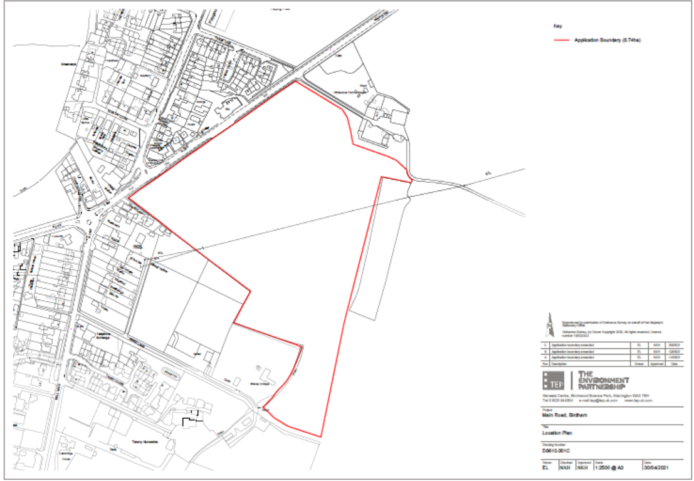
Figure 1 – Land off Main Road, Birdham – Site Location Plan
    - The site was assessed as being ‘Developable’ in the Chichester Housing and Economic Land Availability Assessment 2021 (HELAA ref: HBI00029/29a). The site was concluded by the Council to be suitable, available and achievable and there are no known constraints that would make the development unachievable in principle. Estimated timescales for delivery would be 0-5 years. Gladman fully support the Council’s assessment of the site.
    - The site has good access to social and community infrastructure that would be expected of an edge of settlement location, is not subject to any insurmountable technical or environmental constraints and can accommodate a high-quality residential development that will address identified market and affordable housing needs.
    - The site can deliver a wide range of market and affordable homes to meet Chichester’s existing needs general and specialist housing needs and would be able to deliver quickly, without the need for significant infrastructure, within the early part of the plan period.
    - The site represents one of the few opportunities to deliver development outside of the Chichester Harbour Area of Outstanding Natural Beauty location in the authority and thus the potential for development here should be maximised.
    - Gladman currently have a ‘live’ outline planning application on the site which was submitted to Chichester District Council in June 2021 (application ref: 21/01830/OUT). At the time of writing, the application remains under consideration by the Council.
    - The remainder of this section describes the site’s suitability for residential development in further detail, taking account of the technical studies that have been undertaken to support the delivery of the site to date.
New Homes
    - The site can deliver a wide range of market and affordable homes to meet the district’s general and specialist housing needs and would be able to deliver quickly, without the need for significant infrastructure, within the early part of the plan period. Gladman can confirm that the site can deliver a provision of affordable housing on-site in accordance with local planning policy. This is a significant benefit given the significant level of need for affordable housing across Chichester district.

Community Facilities and Viability
    - Proportionate developer contributions towards the delivery of new community infrastructure would be provided alongside any proposals.
    - Gladman will agree requests for developer contributions which meet the relevant requirements of paragraph 57 of the NPPF and CIL regulations 122 and 123. Gladman would be pleased to agree an initial set of Heads of Terms with Chichester District Council.
Open Space and Green Infrastructure
    - The illustrative Development Framework Plan which supports the application demonstrates how the built development will be set within a framework of open space and green infrastructure. The green space will include a formal locally equipped children’s play area (LEAP), informal open space and a community park. The proposal seeks to retain existing landscape features; enhance the existing hedgerows and where possible any loss will be mitigated elsewhere on site. The illustrative Development Framework Plan incorporates these elements within a strategic landscape framework.
    - Generous areas of informal and formal open space will underpin the proposals for the site. The total area of open space provided as part of the site’s development would meet Chichester District Council’s requirements.
Flood Risk Mitigation
    - Technical work undertaken to date has confirmed that the site is located within Flood Zone 1 (the area at the lowest risk of flooding). The site, therefore, can be developed safely in relation to flood risk and flooding would not pose a constrain to the development of the site.
    - A comprehensive Flood Risk Assessment (FRA) has previously been prepared for the site which demonstrated that the development of the site would be safe for its lifetime taking account of the vulnerability of its users, without increasing flood risk elsewhere, and, where possible, can reduce flood risk overall.
    - SUDs features incorporated in the development will not only operate technically to reduce flood risk, but could also be used to enhance the onsite biodiversity and will be incorporated into the usable green infrastructure to help create high-quality open spaces.
    - Furthermore, site specific information has been provided to the council to demonstrate that the site is at negligible risk of groundwater flooding.
Demonstrating nitrate neutrality
    - The development is located outside of the Chichester Harbour AoNB and naturally drains in a southerly direction. Through the evidence provided in the Flood Risk Assessment and Habitats Regulations Assessment, the development would not create any nitrate waste into the Chichester Harbour protected area.
Highways and Sustainable Transport
    - The site is accessed from Main Road, via a simple priority junction. It has been confirmed that the required visibility splays can be achieved and that the site access junction will operate comfortably within capacity in both the morning and evening peak periods with the proposed development traffic as demonstrated by the Transport Assessment supporting the ‘live’ application. West Sussex County Council Highways Team have raised no objection in response to the current application on the site in relation to expected traffic capacity impacts and available junction capacity.
    - The site benefits from good pedestrian connectivity to the village of Birdham. There are a good range of local amenities and facilities which can be accessed on foot, by cycle or by public transport within nationally recognised acceptable walking and cycling distances. These include, but are not limited to: Nisa Local Shop, Birdham Post Office, Birdham CofE Primary School, Birdham Marina and St James Community Centre which are all within the CIHT ‘preferred maximum walking distance’ guidance.
    - The site is situated on the existing local bus network with stops located along Main Road. Due to the proximity of the existing transport network, it would be appropriate to assume bus to be the most accessible and efficient sustainable transport system for future residents. The no. 52 bus serves The Witterings and Birdham to Chichester City running every 30 minutes. The service provides commutable journey times to Chichester with buses starting at 06:58 and returning as late as 22:13.
    - It is possible for future residents of the proposed scheme to easily access sustainable public transport options to further afield via Chichester Bus Station or Chichester Train Station. Both are easily accessible utilising the no. 52 bus service.
Public Rights of Way
    - The proposals seek to enhance the green gateway to the wider countryside and provide improvements to the existing Public Rights of Way (PRoW). Footpath (FP) 48 currently runs to the north of the site and continues to the east towards Sidlesham Lane. This route features in the Green Links across the Manhood’s (GLaM) statement as GLaM route 8, identified as Mapsons Lane, which is earmarked to be upgraded from an existing farm track to a bridleway.
    - FP48 is of particular importance within Birdham as it connects to the Salterns Way, a Chichester to West Wittering cycle way (via Crooked Lane) in one direction and to Sidlesham Lane / Batchmere Road in the other which leads to Bracklesham and East Wittering. However, the land required to undertake these improvements falls within private ownership, so this aspiration has to date been undeliverable.
    - As part of the development proposals, Gladman is proposing to upgrade the existing FP48/GlaM Route 8 to a minimum 3 metre width and to an agreed specification. Improvements to FP48/GLaM Route 8 could be secured via planning condition, likely requiring the work to begin prior to the occupation of an agreed quantum of housing.
    - In conclusion, there are no outstanding technical objections on the site identified by statutory consultees through the submission of the current ‘live’ planning application on the site.
    - Alongside the delivery of affordable housing, development of the site will offer the opportunity to deliver a number of other benefits, including:
- A commitment to deliver a high-quality development through the inclusion of a design code, which sets a benchmark for further reserved matters applications;
- Significant areas of attractive and diverse greenspace for new and existing local residents including the provision of a community park and a village green;
- Provision of play areas plus recreational footpaths within the site that would be publicly accessible to new and existing residents;
- Securing net gains in biodiversity through the provision of vast green infrastructure and new wildlife habitats and retention and enhancement of existing ones;
- Improvements to local cycle routes, footpaths and PRoW, delivering GLaM Route 8 to a specification that will enable this to become a dedicated Bridleway; and
- An economically active population generating total gross expenditure of approximately £5.4million annually, benefiting the local economy.

Chichester District Council planning application reference: 21/01830/OUT

